|  |  |  |
| --- | --- | --- |
|  |  |  |
| To: | Council |  |
| Date: | 27 January 2025 |  |
| Report of: | Head of Financial Services | | |
| Title of Report: | Housing Revenue Account (HRA) Rent Setting Report 2025/26 | | |

|  |  |
| --- | --- |
| Summary and recommendations | |
| Purpose of report: | To present the outcome of Oxford City Council’s (the council’s) annual rent review and associated rent setting proposal for 2025/26 in respect of all council dwellings within the Housing Revenue Account, including the setting of associated services and facilities charges |
| Key decision: | No |
| Cabinet Member: | Councillor Ed Turner, Deputy Leader and Cabinet Member for Finance and Asset Management  Councillor Linda Smith, Cabinet Member for Housing |
| Policy Framework: | The rent setting forms part of the Budget and Policy Framework document |

|  |  |
| --- | --- |
| Recommendation(s): That Council resolves to: | |
| 1. | Approve an increase of 2.7% for 2025/26 (subject to any subsequent cap on increases imposed by central government) in social dwelling rents from 1st April 2025 giving an average weekly increase of £3.51 per week, and a revised weekly average social rent of £133.68 as set out in the Financial Implications section of this report. |
| 2. | Approve an increase to rents for shared ownership dwellings as outlined in paragraph 21 of the Financial Implications. |
| 3. | Approve an increase to service charges by 2.7% (CPI + 1%) to enable the HRA to recover the associated cost of supply. |
| 4. | Approve an increase to the charge for a garage of 4.1%, equating to an increase of £0.78 per week for a standard garage within a curtilage with a revised charge of £20.00 per week. |

# Appendices to the report:

**Appendix 1** Housing Revenue Account Rent by Ward

**Appendix 2** Risk and Equalities Assessment

# Introduction and background

1. On an annual basis, as part of the Medium-Term Financial Plan (MTFP), the HRA sets the Rent for HRA tenants for the next financial year. The rent setting is governed by two national documents – The Rent Standard, and the Rent Policy Statement.
   1. **The Rent Standard states:** *Registered providers must comply in full with all the requirements and expectations set out in this Rent Standard. They must additionally comply with all the requirements and expectations of the Rent Policy Statement on the setting, increase and decrease of rents and service charges.*
   2. **The Rent Policy Statement defines:**
      1. ***Weekly Formula Rent*** *as 70% of the national average rent; multiplied by relative county earnings; multiplied by the bedroom weight; plus 30% of the national average rent; multiplied by relative property value.*
      2. ***Affordable Rent*** *(inclusive of service charges) must not exceed 80% of gross market rent, where ‘Gross market rent’ means the rent (inclusive of any applicable service charges) for which the accommodation might reasonably be expected to be let in the private rented sector. Property size, location type and service provision must be taken into account when determining what gross market rent a property might achieve if let in the private rented sector.*
      3. ***Rent Flexibility Level*** *- The government’s policy recognises that registered providers should have some discretion over the rent set for individual properties, to take account of local factors and concerns, in consultation with tenants. As a result, the policy contains flexibility for registered providers to set rents at up to 5% above formula rent (10% for supported housing). If applying this flexibility, providers should ensure that there is a clear rationale for doing so which takes into account local circumstances and affordability.*

The maximum increase in both types of rent for 2025/26 is currently restricted to CPI + 1% (CPI as at September in the preceding year). The September 2024 CPI rate was 1.7%, giving a maximum increase of 2.7% subject to any additional cap imposed by the government. *(Ref. GOV.UK Policy Statement on Rents for Social Housing)*

1. As well as the restriction on maximum increases, rents are also capped as follows:
   1. Social Rent – rent caps apply as a maximum ceiling on the formula rent and depend on the size of the property (the number of bedrooms it contains). Where the formula rent would be higher than the rent cap for a particular size of property, the rent cap must be used instead. *(Ref. GOV.UK Policy Statement on Rents for Social Housing)*
   2. Affordable Rents - The rent for affordable rent housing (inclusive of service charges) must not exceed 80% of gross market rent. ‘Gross market rent’ means the rent (inclusive of any applicable service charges) for which the accommodation might reasonably be expected to be let in the private rented sector. Property size, location type and service provision must be taken into account when determining what gross market rent a property might achieve if let in the private rented sector. *(Ref. GOV.UK Policy Statement on Rents for Social Housing)*
2. The HRA must adhere to these restrictions and caps on rent increases even if a tenant’s rent is below formula rent, or if the HRA has previously applied a lower – or no – annual increase. Where this is the case, the HRA may only move the rent up to formula rent when the property is re-let following vacancy (subject to the rent cap).
3. The table below demonstrates the amount of rental income foregone because of these restrictions, including 2023/24’s cap of 7% maximum increase when the actual CPI rate was 10.1% :

|  |  |  |  |
| --- | --- | --- | --- |
|  | **Number of Properties** | **Total Weekly Rent Foregone** | **Total Annual Rental Income Foregone** |
| Actual Rent is less than Formula Rent | 7,134 | £76,724 | £4,066,372 |

1. One additional consideration is for OCC to join other social housing providers in lobbying government (MHCLG) for the re-introduction of rent-convergence measures to address the gap between actual rents of £53.89m and formula rents of £57.96m. Currently this is an annual loss to the HRA of £4.07m
2. The government recently opened a consultation on the future of the Social Housing Rent Policy including proposals for a 5-year rolling settlement. The council submitted its response prior to the consultation deadline of the 23rd December 2024.
3. Housing Stock

As at 1st April 2024 the HRA held 7,869 dwellings, as shown below:

|  |  |  |  |  |  |  |  |
| --- | --- | --- | --- | --- | --- | --- | --- |
|  | **Number of bedrooms** | | | | | |  |
|  | **0** | **1** | **2** | **3** | **4** | **5+** | **Total** |
| **Flat / Maisonette** | 163 | 1,257 | 1,743 | 162 | 5 |  | **3,330** |
| **House / Bungalow** |  | 272 | 834 | 2,785 | 256 | 35 | **4,182** |
| **Housing for Older People** |  | 266 | 26 |  |  |  | **292** |
| **Shared ownership** |  | 31 | 31 | 3 |  |  | **65** |
| **Totals** | **163** | **1,826** | **2,634** | **2,950** | **261** | **35** | **7,869** |

1. Types of Rent

There are two types of rent charged within the HRA:

* **Social Rent** - Since 2001, rents for properties let at ‘social rent’ (which constitute a majority of rented social housing properties) have been set based on a formula set by government. This creates a ‘formula rent’ for each property, which is calculated based on the relative value of the property, relative local income levels, and the size of the property.
* **Affordable Rent** - In 2011, the government introduced ‘affordable rent’ which permits rents to be set at up to 80% of market rent (inclusive of service charges).

1. A table of the highest rents charged by OCC HRA is shown below:

|  |  |  |
| --- | --- | --- |
|  | **2024/25 Highest Weekly Rents** | |
| **No. of Bedrooms** | **Social Rent** | **Affordable Rent** |
| 1 and bedsits | £148.68 | £205.55 |
| 2 | £199.09 | £251.92 |
| 3 | £210.15 | £303.69 |
| 4 | £221.19 | N/A |
| 5 | £232.26 | N/A |
| 6 or more | £243.31 | N/A |

1. Social rent caps for 2025-26 as set by the Government are:

| **Number of bedrooms** | **Rent cap** |
| --- | --- |
| 1 and bedsits | £194.06 |
| 2 | £205.46 |
| 3 | £212.87 |
| 4 | £228.27 |
| 5 | £239.69 |
| 6 or more | £251.10 |

Housing Benefit / Universal Credit Housing Cost Element

1. As at the end of September 2024 there were a total of 5,149 HRA tenants (67%) claiming Housing Benefit or the Housing Cost element of Universal Credit, made up of 1,875 Housing Benefit claimants and 3,274 Universal Credit claimants. The amount claimed by each tenant will vary depending on their individual circumstances.

As Social Rents are based on formula rent, the maximum amount housing benefit will cover is 100% of the rent depending on the tenants’ eligibility and financial circumstances.

1. For Affordable Rents, the current Local Housing Allowance Rates for Oxford are set out below. These are the maximum eligible rents to be used when calculating Housing Benefit for Affordable Rental Properties.

| **Local Housing Allowance Rates for 2024/25** (Not yet available for 2025/26) | | |
| --- | --- | --- |
| **Number of Bedrooms** | **£ per week** | **£ per month** |
| Room in Shared Accommodation | 126.58 | 550.02 |
| 1 Bedroom | 207.12 | 899.99 |
| 2 Bedrooms | 258.90 | 1,124.98 |
| 3 Bedrooms | 304.93 | 1,324.99 |
| 4 Bedrooms | 402.74 | 1,750.00 |

# Financial implications

1. A recent HRA Strategic Review undertaken by external consultants identified that the HRA faced an uncertain financial future within the next 10 years due to the scale of investment required because of the demands placed on it by new legislation and housing standards. As a result, the HRA needs to maximise its income streams where permissible. Implementing the maximum rent increase allowed by government would help the HRA to meet its legal obligations and remain viable going forward.
2. A rent increase that is lower than inflation will have a detrimental impact on the viability of the HRA as the income will not be able to keep pace with rising costs and as a consequence would be at risk of failing its tenants in the supply of services and support.
3. The CPI rate for the 12 months to the end of September 2024 was 1.7% giving a proposed increase of 2.7%. Average weekly social rents by ward are provided in Appendix 1 alongside the proposed increases and Formula Rent. For comparison purposes the impact on a range of rents is shown in the table below using the rate of CPI+1% of 2.7% :

|  |  |  |  |  |  |
| --- | --- | --- | --- | --- | --- |
| Rent Increase | Weekly Increase based on **Average Social Rent** of £130.17 | Weekly Increase based on **Maximum Social Rent** of £243.31 | Weekly Increase based on **Average Affordable Rent** of £231.57 | Weekly Increase based on **Maximum Affordable Rent** of £303.69 | Total Annual Increase to HRA Rental Income |
| 2.7% | £3.51 | £6.57 | £6.25 | £8.20 | £1.455m |

1. For comparison purposes, in the 12 months to December 2024 private sector rents in Oxford rose by an average 8.6% meaning the average rent increased from £1,648 to £1,789 per month (£412.85 per week). See Chart Below.

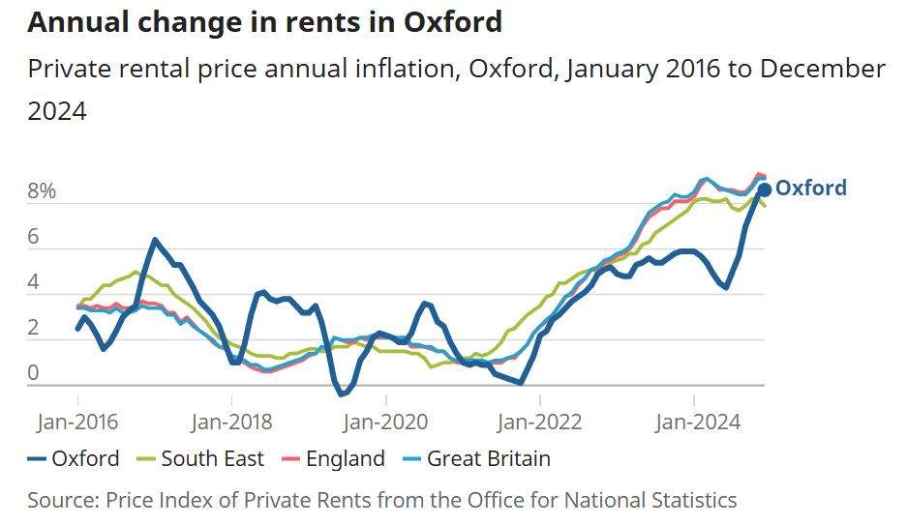

1. The rent increase for Shared Ownership will be CPI + 1% based on the CPI rate for the 12 months to the end of September 2024. This will only apply for shared ownership properties owned for the whole of the preceding 12 months (ie. before 1st October 2023). For properties purchased after the 30th September 2023 the increase for 2025/26 will be 0.5%.

The rent rise included in the Consultation Budget under these agreements is effectively an increase of 0.5% for properties less than 12 months old (as at 30th September 2024) of which the council currently has 8 such properties and CPI + 1% (2.7%) for older properties of which the council has 56 properties.

1. As part of the Council’s MTFP proposals for 2025/26 the charge for garages within curtilage is proposed to be increased by 4.1% from £19.22 to £20.00 per week, and is consistent with the charge for a standard garage not within curtilage, and up from £21.71 to £22.60 per week for a premium garage.
2. The increase in the charge for garages equates to £0.78 per week at 4.1% and will generate an additional £8,274 per annum for the HRA. For comparison purposes, if the garage charge was increased by 2.7% this would increase the weekly charge by £0.54 and generate an additional £5,516 per annum for the HRA, a difference of £2,772.
3. Service charges such as caretaking, cleaning, CCTV, communal areas etc. will be increased by CPI plus 1% across all tenure types in the HRA to ensure that the HRA recovers the cost of providing these services. Service charges will be monitored and reviewed regularly to ensure costs of provision are being recovered and tenants are not being overcharged.

# Legal issues

1. The rent setting is governed by two government documents – The Rent Standard (Regulator of Social Housing), and the Policy Statement on Rents for Social Housing (GOV.UK).
2. The HRA is a ring-fenced account and is required to finance its activities from the income it generates - predominantly rental income. Failure to maintain a positive balance of the HRA account would lead to the collapse of the HRA at Oxford City Council.

**Risk Implications**

1. The main risk to the HRA is that the increases are not approved resulting in an unsustainable financial position that would require significant reductions in the provision of services and support to its residents.

# Equalities impact

1. See Appendix 2.

**Carbon and Environmental considerations**

1. This report is for rent setting purposes, and the proposed budget changes do not affect the council's ability to reach our net zero target.

|  |  |
| --- | --- |
| **Report author** | Jason Jones |
| Job title | Finance Business Partner |
| Service area or department | Finance |
| Telephone | 01865 252365 |
| e-mail | jajones@oxford.gov.uk |

|  |  |
| --- | --- |
| Background Papers: | |
| 1 | GOV.UK: Policy statement on rents for social housing <https://www.gov.uk/government/publications/direction-on-the-rent-standard-from-1-april-2020/policy-statement-on-rents-for-social-housing> |
| 2 | Regulator of Social Housing: Rent Standard  <https://assets.publishing.service.gov.uk/media/65e741ce2f2b3b0ba97cd774/Limit_on_annual_rent_increases_2024-25.pdf> |
|  |  |

**Please note in the table below the version number of your report that was finally cleared at each stage**

|  |  |
| --- | --- |
| **Report Stage** | **Version Number** |
| **First Draft:**  *Commissioned and cleared by Director* | v1 |
| **Second Draft:**  *Cleared by Legal and Finance* | v1 |
| **Final Draft:**  *Cleared by the Board Member* | v2 |
| **Final Report:**  *Cleared by Labour Group* | v2 |